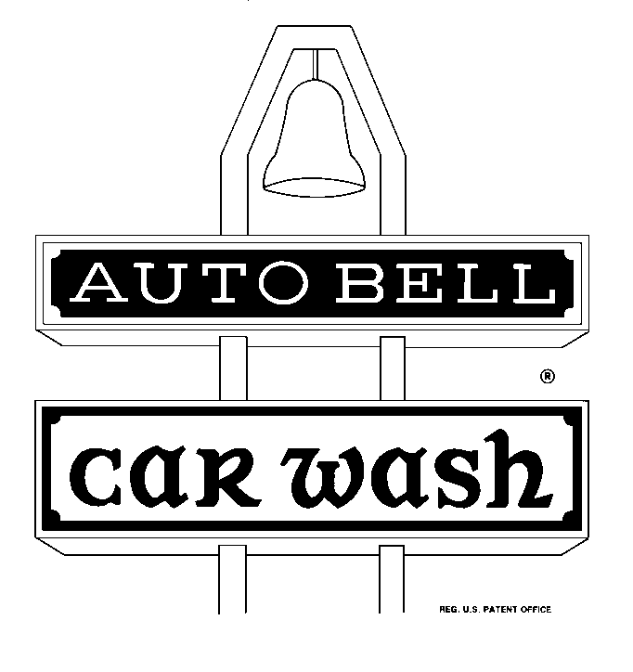 | 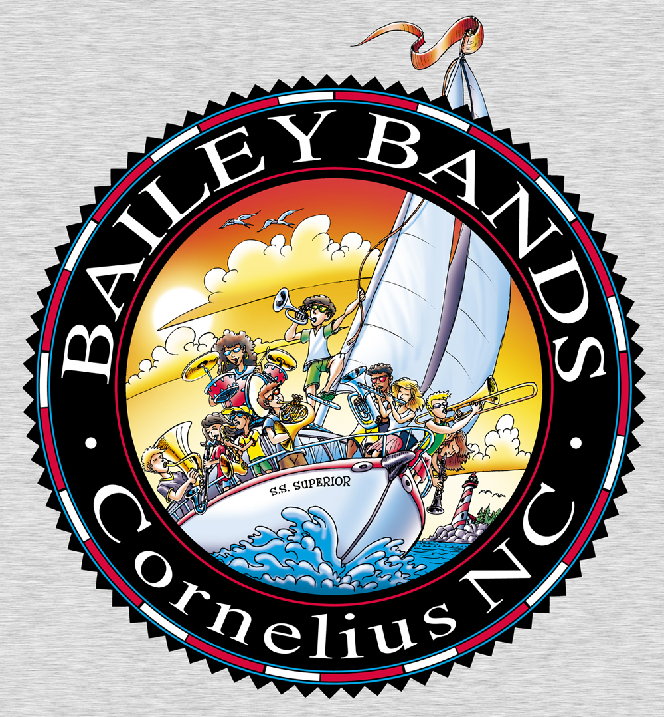

AUTOBELL CAR WASH & BAILEY MIDDLE SCHOOL BAND BOOSTERS
Gift Card Sale
Make checks out to Bailey Band Boosters.

Regular Full Service Car Wash = $20.00
Vacuum carpet and seats. Dust inside. Towel-dry exterior. Clean interior/exterior windows.

Band Student __________________________________________

Name | Address | Phone | Qty | Cost | Paid

